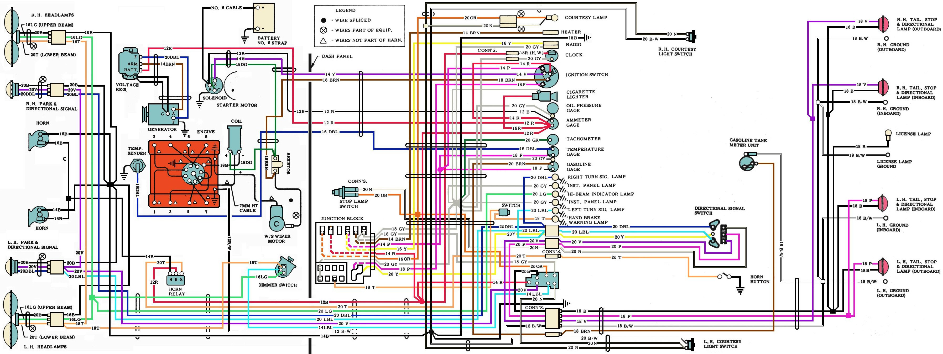

This drawing contains the ammeter wiring error – the leads coming to the rear of the ammeter need to be reversed. If it wired in as presented on this drawing the meter will show a discharge when charging.

This is set up to print on 8.5”X14” paper. You will find, the bigger the paper the better.

I’ve had this drawing for a number of years – downloaded from the Internet. Ron Dill

